Capstone Project
Develop a YouTube Clone Using the MERN Stack

Name: Udugundla Praveen
Git repository: https://github.com/Praveen775D/youtube-clone
Gmail: upraveen776@gmail.com
Demo Video: https://drive.google.com/file/d/1GOhgaAn_cBCUveL6nKoq9bH2Qgd_XBS-/view?usp=drive_link

Table of Contents
1. Project Overview
2. Objectives of the Project
3. Tech Stack
3.1 Client
3.2 Server
4. System Architecture
5. Project Structure
5.1 Client (Frontend)
5.2 Server (Backend)
6. Features
6.1 Authentication
6.1.1 Registration
6.1.2 Login
6.2 Home Page
6.2.1 Features
6.2.2 Navigation
6.3 Video System
6.4 Channel System
6.4.1 Channel Creation
6.4.2 Channel Page Features
6.5 Video Upload & Streaming Flow
6.6 Comment System Flow
7. API Endpoints Explanation
7.1 Authentication APIs
7.2 Video APIs
7.3 Channel APIs
8. File Upload System
8.1 Storage
8.2 Future Location
9. Database Schema Overview
10. Installation & Setup
11. Future Enhancements
12. Conclusion

- Project Overview
YouTube Clone (MERN Stack)
A full-stack YouTube Clone built using the MERN stack (MongoDB, Express.js, React, Node.js).
This application replicates real-world video streaming platform features including video upload, playback, authentication, and channel management.
This project is a full-stack YouTube Clone built using the MERN stack.
It allows users to:
- Register and login securely
- Create their own channel
- Upload videos with thumbnails
- Watch and interact with videos
- Like, dislike, comment, and subscribe
The goal is to replicate the core functionality of a real-world video streaming platform.
2. Objectives of the Project
The main objectives are:
- To understand full-stack development
- To implement real-world features like authentication and file uploads
- To follow clean architecture (MVC pattern)
- To build a scalable and maintainable application
3.Tech Stack
3.1 Client
- React (Vite) → Fast UI development
- Tailwind CSS → Modern styling
- Axios → API communication
- React Router → Page navigation
3.2 Server
- Node.js → Server runtime
- Express.js → API framework
- MongoDB → NoSQL database
- Mongoose → Schema modeling
- JWT → Authentication
- Multer → File upload handling
4. System Architecture
The application follows a Client–Server Architecture, where the frontend and backend communicate through REST APIs, and data is stored in a MongoDB database.
Architecture Flow
[ User (Browser) ]
↓
[ React Frontend (Client) ]
↓ (API Calls - Axios)
[ Node.js + Express Backend ]
↓
[ MongoDB Database ]
↓
[ File Storage (Uploads Folder) ]
Detailed Explanation
Frontend (Client)
- Built using React
- Handles UI/UX
- Sends API requests using Axios
- Manages state and routing
Backend (Server)
- Built using Node.js and Express
- Handles:
  - Authentication (JWT)
  - Video upload (Multer)
  - Business logic
- Exposes REST APIs
Database (MongoDB)
- Stores:
  - Users
  - Channels
  - Videos
  - Comments
File Storage
- Stores:
  - Video files
  - Thumbnails
  - Channel images
5. Project Structure
5.1 Client (Frontend)
client/
│
├── public/
├── src/
│ ├── api/
│ │ └── axios.js # API config + interceptors
│ ├── assets/ # Images/icons
│ ├── components/ # Reusable UI components
│ │ ├── Navbar.jsx
│ │ ├── Sidebar.jsx
│ │ ├── VideoCard.jsx
│ │ ├── CategoryBar.jsx
│ │ └── CommentSection.jsx
│ ├── context/ # Global state
│ │ ├── AuthContext.jsx
│ │ └── PreviewContext.jsx
│ ├── hooks/
│ │ └── useAuth.js
│ ├── pages/ # Main pages
│ │ ├── Home.jsx
│ │ ├── VideoPage.jsx
│ │ ├── UploadVideo.jsx
│ │ ├── ChannelPage.jsx
│ │ ├── CreateChannel.jsx
│ │ ├── EditChannel.jsx
│ │ ├── EditVideo.jsx
│ │ ├── Studio.jsx
│ │ ├── Login.jsx
│ │ └── Register.jsx
│ ├── utils/
│ │ └── media.js # media helpers
│ ├── App.jsx # Routing
│ ├── main.jsx # Entry point
│ └── index.css
├── index.html
├── package.json
├── vite.config.js
└── tailwind.config.js
5.2 Server (Backend)
server/
│
├── config/
│ └── db.js # MongoDB connection setup
├── controllers/ # Business logic (core functionality)
│ ├── authController.js
│ ├── channelController.js
│ ├── commentController.js
│ └── videoController.js
├── middleware/ # Reusable middlewares
│ ├── authMiddleware.js # JWT protection
│ └── uploadMiddleware.js # File upload (Multer)
├── models/ # MongoDB schemas
│ ├── User.js
│ ├── Channel.js
│ ├── Video.js
│ └── Comment.js
├── routes/ # API routes
│ ├── authRoutes.js
│ ├── channelRoutes.js
│ ├── commentRoutes.js
│ └── videoRoutes.js
├── uploads/ # Stored media files
│ ├── avatars/
│ ├── banners/
│ ├── thumbnails/
│ └── videos/
├── seeder/
│ └── seedVideos.js # Dummy data script
├── utils/
│ └── generateToken.js # JWT token generation
├── .env # Environment variables
├── server.js # Entry point
├── package.json
└── package-lock.json

6. Features
6.1 Authentication
- Users can register and login using mail and password and other option user direct google login
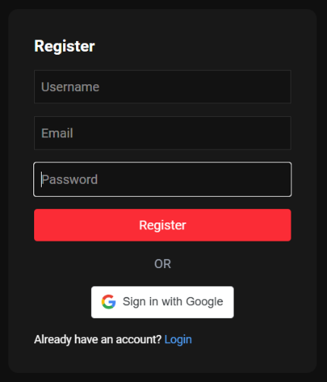
- JWT (JSON Web Token) is used for secure authentication
- Protected routes ensure only logged-in users can upload videos
6.1.1 Registration
Users can create an account using:
- Enter Username, Email, Password manually
- Or use Google Sign-Up for quick registration
6.1.2 Login
Users can access their account using:
- Email & Password login
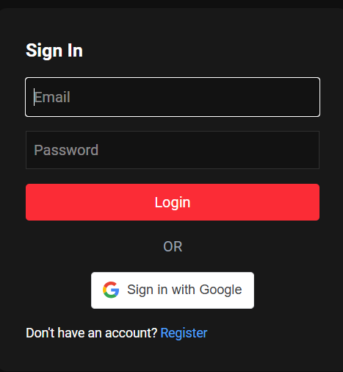
- Or Google Login for instant access
- User logs in
- Backend generates JWT token
- Token stored in localStorage
- Every request sends token
- Backend verifies token

6.2 Home Page
The Home Page is the main landing page of the application where users can explore videos.
6.2.1 Features
- Displays a list of all uploaded videos
- Shows thumbnail, title, channel name, and views
- Videos are arranged in a responsive grid layout
6.2.2 Navigation
- Users can click on any video to open the Video Player Page
- Sidebar and category filters help in browsing content
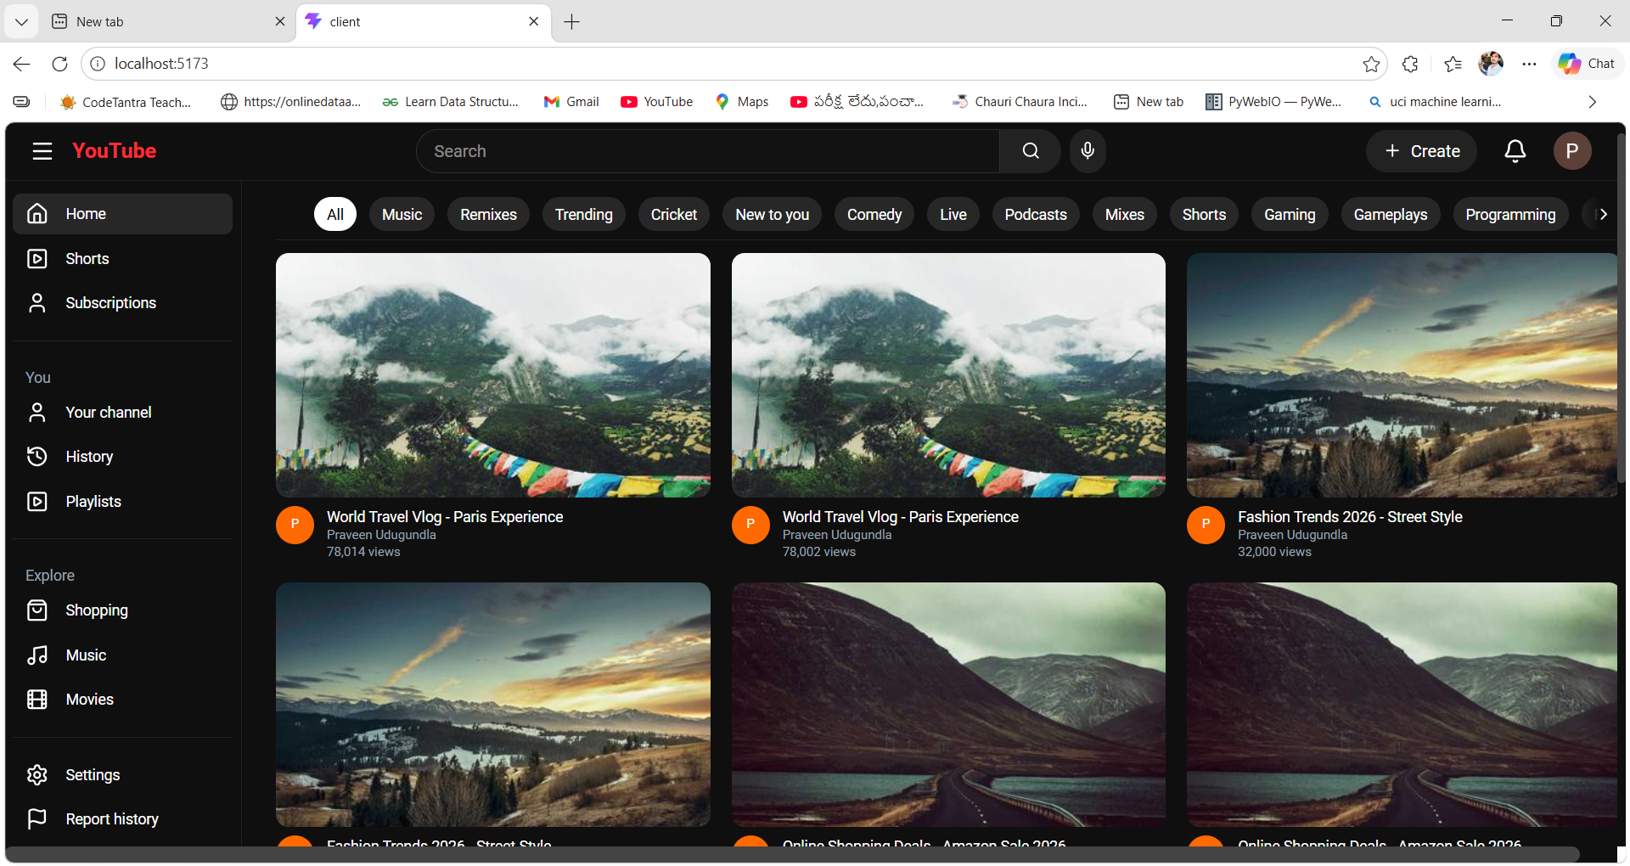
6.3 Video System
- Users can upload videos with thumbnails
- Videos are stored on the server
Users can:
  - Play videos
  - Like / Dislike
  - View count increases automatically
  - Recommended videos are shown
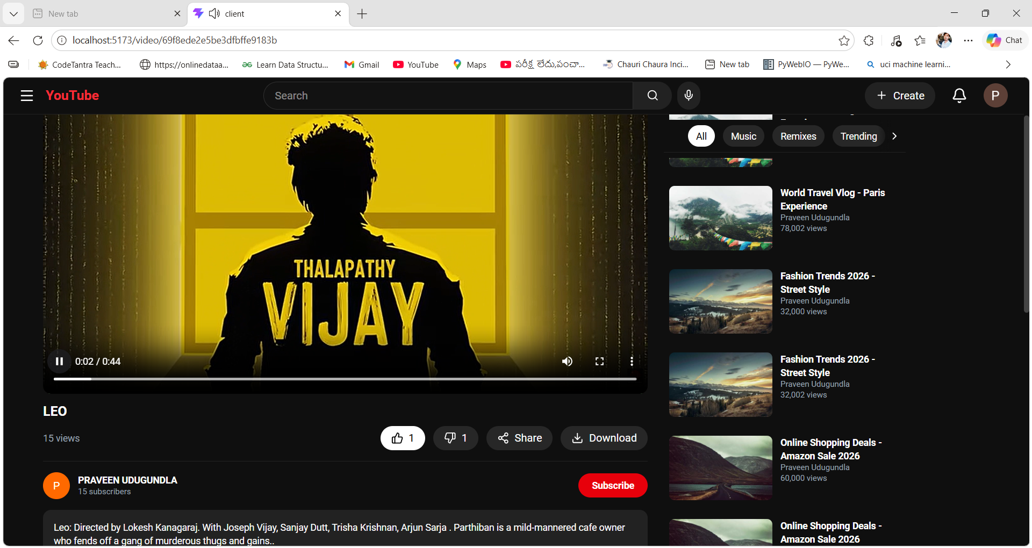

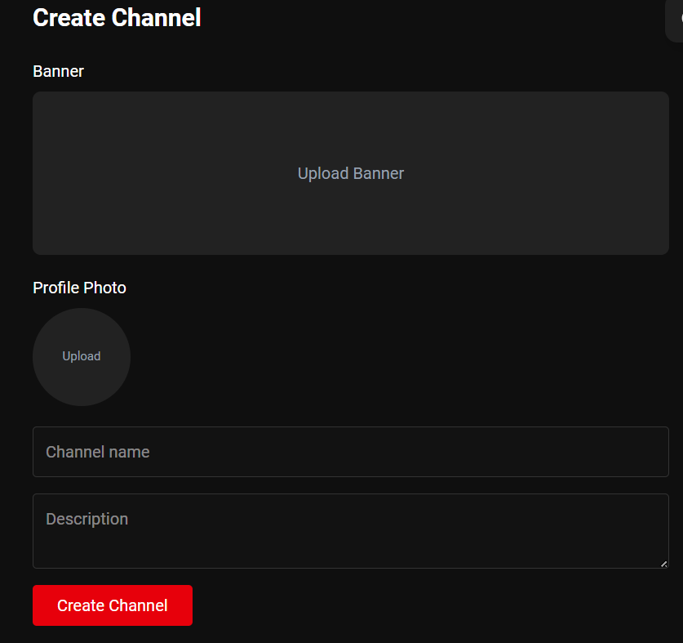
6.4 Channel System
6.4.1 Channel Creation
- Each user can create one unique channel
- Channel includes:
  - Channel name
  - Description
  - Profile avatar
  - Banner image
6.4.2 Channel Page Features
The channel page displays:
- Channel details (name, avatar, banner, description)
- All uploaded videos of the channel
- Total subscribers count
User Interactions
- Subscribe to a channel
- Unsubscribe from a channel
Channel Owner Controls
- Upload new videos
- Edit channel details
- Delete or manage their videos
Each channel maintains:
- List of uploaded videos
- Subscriber count
- Channel owner information
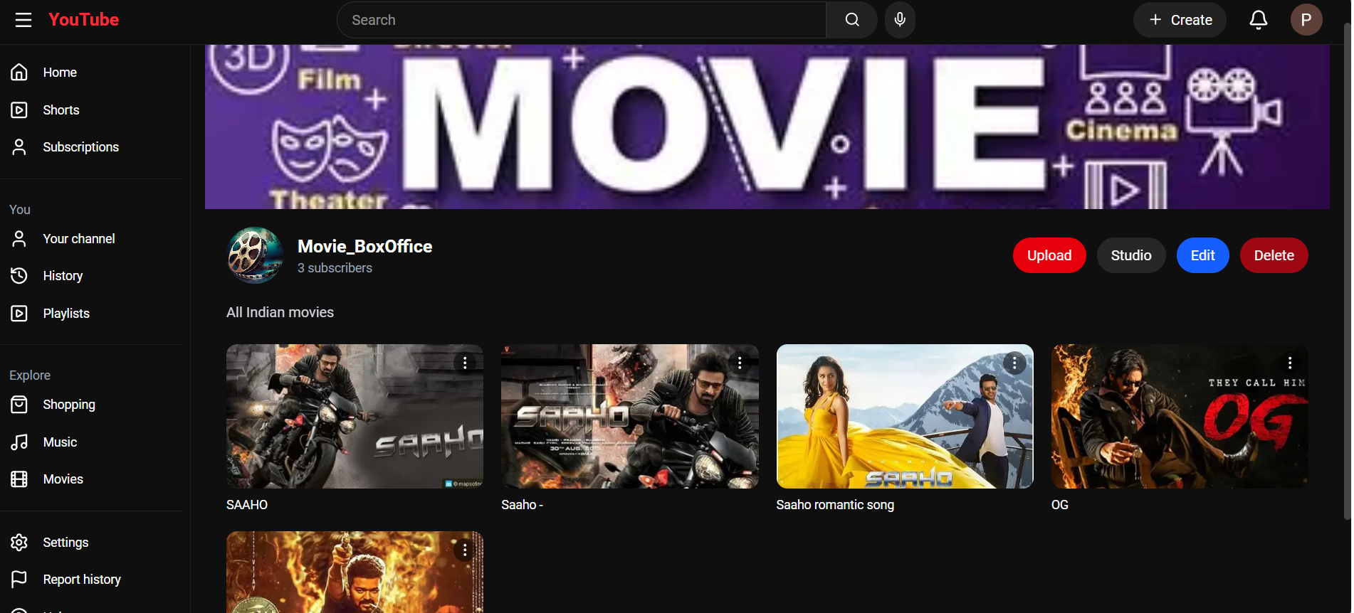
6.5 Video Upload & Streaming Flow
- User selects video & thumbnail
- Data sent using FormData
- Multer stores files in /uploads
- Video data saved in MongoDB
- Video is played using <video> tag
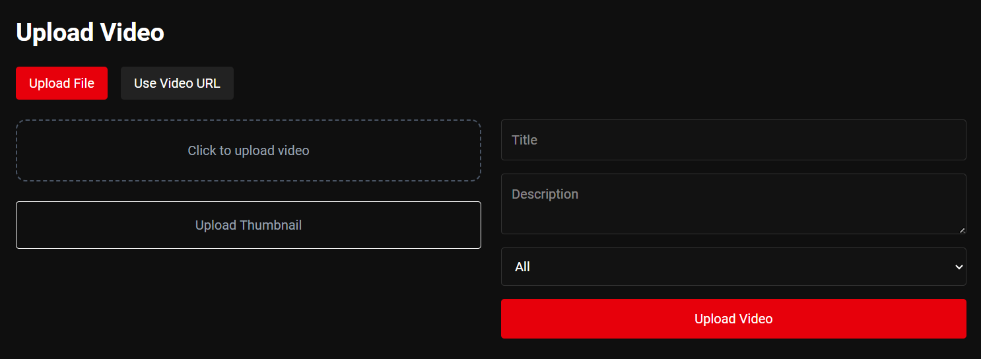
6.6 Comment System Flow
- User posts comment
- Comment saved in DB
- Linked to video
- Displayed in UI
Comment System
- Users can comment on videos
- Edit/Delete functionality is available
- Comment count is maintained
- upload handling
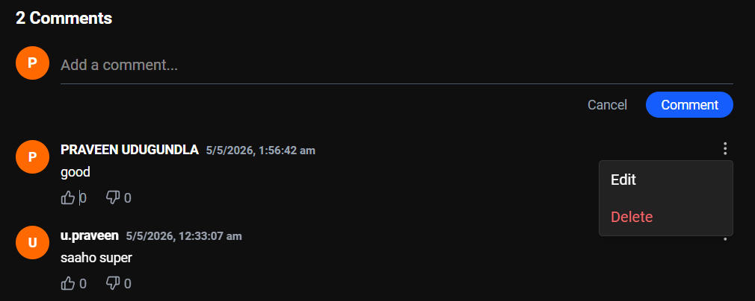
7. API Endpoints Explanation
The backend exposes RESTful APIs to handle authentication, video management, and channel operations.
7.1 Authentication APIs
- Register User
Creates a new user account using username, email, and password.
- Login User
Authenticates the user and returns an access token for secure communication.
7.2 Video APIs
- Get Videos
Fetches all videos with support for search, category, and pagination.
- Upload Video
Allows authenticated users to upload videos along with thumbnails and metadata.
- Like / Dislike Video
Enables users to interact with videos and updates engagement metrics.
7.3 Channel APIs
- Create Channel
Allows a user to create their personal channel.
- Subscribe / Unsubscribe
Users can follow or unfollow channels, updating subscriber count.
8. File Upload System
The application uses Multer middleware to handle file uploads.
8.1 Features
- Upload video files
- Upload thumbnail images
8.2 Storage Locations
- Videos → uploads/videos/
- Thumbnails → uploads/thumbnails/
This system ensures efficient handling and storage of media files on the server.
9. Database Schema Overview
The application uses MongoDB to store structured data.
User Collection
- username → User’s name
- email → Unique email address
- password → Encrypted password
- channelId → Reference to user’s channel
Video Collection
- title → Video title
- videoUrl → Path to video file
- thumbnailUrl → Thumbnail image path
- views → Number of views
- likes → List of users who liked
Channel Collection
- name → Channel name
- subscribers → Subscriber count
- videos → List of uploaded videos

10. Installation & Setup
Follow these steps to run the project locally.
Server Setup (backend)
- cd server
- npm install
- npm run dev
Client Setup (frontend)
- cd client
- npm install
- npm run dev

11. Future Enhancements
- Automatic thumbnail generation from videos
- AI-based video recommendations
- Live streaming feature
- Notification system for updates

12. Conclusion
This project demonstrates strong full-stack web development capabilities by integrating a modern frontend with a scalable backend architecture. It reflects real-world application design principles, including clean and modular code structure, efficient data handling, and secure authentication mechanisms. The seamless interaction between frontend and backend ensures a smooth user experience, while the organized architecture makes the application maintainable and extensible. Overall, this project showcases the ability to build a complete, production-ready web application following best practices.

